Lal Salam to the Martyrs of the Indian Revolution!
The Communist Party of Turkey Marxist-Leninist (TKP-ML) extends its greetings to the Communist Party of India (Maoist) on its Martyrs’ Memorial Week, held from 28 July to 3 August. Our party sends its solidarity greetings to the Communist Party of India (Maoist) and all revolutionary forces in India.
On behalf of the revolutionary movement in Turkey and Turkish Kurdistan, our party commemorates the martyrs who made the greatest sacrifices in the resolute struggle of Indian revolutionaries against imperialism, feudalism, bureaucratic capitalism and fascism, led by the CPI (Maoist) in India. We offer our deepest revolutionary respects. The heroes of the Indian people, who sacrificed their lives in the struggle for national and social liberation, are also heroes of the Turkish and Kurdish nations and of our people from various nationalities and beliefs.
Last year, approximately 357 revolutionary fell on the path of the protracted people’s war outlined by the great leaders of the Indian revolution, the founding leaders of your party, and our teachers, Comrade Charumajumdar and Comrade Kanhai Chatterjee. Of these, 136 were female comrades, and 34 were peasants.
We bow with respect before the revolutionary struggles of all our martyrs, including the former General Secretary Comrade Basavaraju (Nambala Keshava Rao), who fell alongside 27 comrades on 21 May, and four Central Committee members who fell at different times.
A significant part of these martyrs were killed during the counter-revolutionary ‘Kagaar Operation’ launched by the fascist Hindutva Indian state. The reactionary forces of India are setting a deadline to eliminate the Maoist movement. However, their grave mistake will soon become evident. On one side of the reactionary Indian state’s attack campaign against the Maoists is the unrestricted opening of India’s natural resources to imperialist and comprador capital for plundering, while on the other side there is the struggle led by the CPI (Maoist), which constitutes one of the most advanced positions of the international proletariat and the oppressed peoples of the world.
Imperialists and their regional reactionary lackeys are using all available means and opportunities to eliminate communist and revolutionary resistance centres they perceive as an immediate and real threat to themselves. For this reason, global reaction is engaged in full-scale aggression on the international stage. What is happening in Gaza should not be understood merely as the genocide and massacre of Palestinians. What is actually happening should be seen as a preview of the future that the imperialist capitalist system promises to the working class and the oppressed peoples of the world. A clear message is being sent to every class and oppressed people who refuse to submit to imperialist capitalism, who are in any way contrary to the order, and who oppose the established system. Today’s Gaza is tomorrow’s world.
In this sense, we view the martyrs who have become immortal in the struggle for a New Democratic India and Socialism against the imperialist capitalist system and the reactionary Indian state as a symbol of our determination to struggle, and we draw inspiration from the revolutionary struggle of the Indian working class and people. The names of all the martyrs, especially Comrade Basavaraju, stand at the forefront among the immortal heroes of India’s epic people’s war and the revolutionary struggles for national liberation and socialism worldwide. They raised the banner of armed struggle in India at the cost of their lives and blood, inspiring proletarian revolutionary forces worldwide to persevere in the struggle against the aggressiveness of the imperialist capitalist system.
On this occasion, the Central Committee of the CPI (Maoist) calls upon all party members, PLGA forces, revolutionary workers, and the entire people to commemorate all the martyrs, draw inspiration from their sacrifices, revolutionary resolve, and fighting spirit, and to protect the party, the PLGA, the united movement/people’s organisation, and the revolutionary movement, and to resist the counter-revolutionary “Kagar” offensive launched by the state governments to destroy the revolutionary movement across the country.
Martyrs, never die!
Long live the Communist Party of India (Maoist)!
Long live Marxism-Leninism-Maoism!
Long live Proletarian Internationalism!
TKP-ML Central Committee
27 July 2025
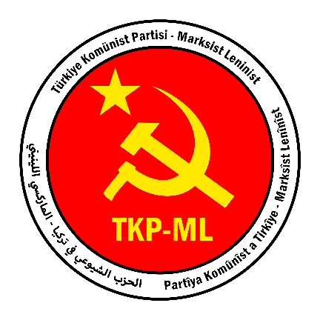

Link: https://www.tkpml.com/tkp-ml-central-committee-lal-salam-to-the-martyrs-of-the-indian-revolution/?swcfpc=1

